

JNEC

RULES GOVERNING JUNIOR NATIONAL EQUESTRIAN

CHAMPIONSHIP: 2020

Article 501

CATEGORIES

YOUNG RIDER (16 to 21 Years)

Dressage - Individual and Team

Jumping Normal - Individual and Team
Eventing - Individual and Team
Tent Pegging - Individual
Jumping (Take your line) - Individual
Endurance - All rides upto 40 kms in one day.
- Individual and Team

JUNIOR (14 to 18 Years)

Dressage - Individual and Team

Jumping Normal - Individual and Team
Eventing - Individual and Team
Endurance - All rides upto 40 kms in one day.
- Individual and Team
Jumping Accumulator/ - Individual
Top Score/Knock Out/
Fault & Out

CHILDREN – I (12 to 14 Years)

Dressage - Individual and Team

Jumping Normal - Individual and Team
Accumulator - Individual

CHILDREN – II (10 to 12 Years)

Dressage - Individual and Team

Jumping Normal - Individual and Team
Accumulator - Individual

Article 502

ELIGIBILITY OF RIDERS IN NEC / REGIONAL SENIOR EVENTS

- In Dressage and Jumping a Young rider / Junior rider, 16 years and above, can participate in a NEC / Regional Senior event in the same show on a appropriately graded horse without effecting their JNEC status.

- In Eventing, a Young rider / Junior rider 16 years and above, can participate in a NEC / Regional Senior event in the same show, without effecting their JNEC status, but not on a horse that is entered in the senior category with another senior rider in the same show.

- In Endurance a YR / J rider 14 years and above, can participate in a NEC / Regional Senior event in the same show, without affecting their JNEC status, but not on a horse that is entered in the senior category in the same show.

- In Tent Pegging, a Young rider / Junior rider 16 years and above, can participate in a NEC / Regional Senior event in the same show without effecting their JNEC status.

- FEI World Challenge Children Dressage & FEI International Children's Jumping Competition is open to riders aged 12 to 14 yrs.

- Since there is an overlap of age in all categories, the rider has the choice to participate in a higher category in the JNEC. However, once a rider decides to participate in a particular category he/she can be downgraded only the next year. Such riders can further upgrade themselves in subsequent JNEC's only once they are in the age bracket of the category to which they upgraded themselves.

- For participation in International competitions the lower age limit is 16 years.

Article 503


SHOW JUMPING

Standards for show jumping competitions :- (Min 50% of the jumps will be of full height and spread to include three vertical and three parallel jumps).

 | Grade | Height |  | Spread | Speed Per | No. of | No of Jumps
 |  |  |  | Max | Min | Round
 |  | Min | Max | Max | Min | Round
 | YOUNG RIDER | 1.05 | 1.15 | 1.35 | 350 M | Two | Maximum of 14 obstacles
 |  |  |  |  |  |  | with a Liverpool and triple
 |  |  |  |  |  |  | combinations in round 2.
 | JUNIOR | 1.00 | 1.05 | 1.25 | 350 M | Two | 14 obstacles with a Liverpool
 |  |  |  |  |  |  | and two double combination
 |  |  |  |  |  |  | in round 2.
 | CHILDREN-I | - | 0.90 | 1.05 | 325 M | One | Max 12 obstacles with one
 |  |  |  |  |  |  | double combination.
 | CHILDREN-II | - | 0.80 | 0.90 | 325 M | One | Max 12 obstacles with one
 |  |  |  |  |  |  | double combination.
Article 504

- All horses above 4 yrs of age can participate. There is no restriction on the grade of horses participating except Grade-I & Grand Prix. However if the rider or his/her parents own the horse, he/she may participate with that horse.

- Abuse of horses:- As per FEI Rules.

- Jump Off :- Jump off will be for 2nd or 3rd place also if there are two or more competitors placed equally. Specially for CSI Y / CSI B selection competitions. For team event there will be no jump off. Team placing will be decided on the timing of 2nd rounds.

Article 505

DRESSAGE

- DRESSAGE TEST DETAILS

Young Rider - |  | Appendix “A” Spurs mandatory.
Junior | - | Appendix “B” Spurs mandatory.
Children I | - | Appendix “C” Spurs optional.
Children II | - | Appendix “D” Spurs optional.
Eventing | - | Appendix “E” Spurs optional.

- RESTRICTION ON HORSES

All horses above 4 yrs of age can participate. No restriction on grade of horses participating. (Except Prix St George & Inter-I). However if the horse belongs to him/her parents, he/she will be allowed to participate.

- BITTING RULES FOR DRESSAGE

Young Rider | - | Snaffle only.
Junior | - | Snaffle only.
Children I | - | Snaffle only.
Children II | - | Snaffle only.

Article 506

EVENTING

JNEC EVENTING

- General: - The JNEC Eventing comprises of 3 distinct tests in 3 disciplines will be held over a period of two or three days depending availability of time and schedule of events.

(a) Competitor rides the same horse throughout.

(b) Dressage is held the first,

(c) Followed by Cross country and jumping (CH format).

- Eligibility/Restriction on horses: - All horses 4 years of age and above are eligible. There is no restriction on the grade of horses.

- Dressage Test : Attached (Appendix 'E') as per CCI* competition (FEI).

- Cross Country Test :-

(a) TECHNICAL SPECIFICATIONS JNEC EVENTING( Novice Eventing):-

OBSTACLES | JNEC EVENTING
HEIGHTS | JNEC EVENTING
Fixed | 0.95m
Brush | 1.15m
SPREADS
At Highest Point | 1.15m
Base spread | 1.60m
Ditches | 1.80m
Drops – (maximum one) | 1.20m
Height of obstacle at water | 0.75m
Water Depth entry to exit | 0.30m
Minimum width of crossing | 09m

COURSE | JNEC EVENTING
Speed | 480 mpm
Distance | 1920-2160m
Number of Efforts | 20-24

JUMPING TABLE | JNEC EVENTING
Length | 350-450m
Speed | 350mpm
No Obstacles/Max Efforts | 11-12
Maximum Height | 1.00m
Spreads | 1.20m
Base of Triple Bar | 1.50m
Combinations | Double (only one)
Min Specifications | 2/3 full height & spread

(b) TYPES OF CROSS COUNTRY OBSTACLES:-

TYPE | JNEC EVENTING (20-24 Efforts)
Upright / Vertical | 3-5 fences, min frontage  3.50m, ascending with ground line
Ascending Oxer | 3-5 fences, min frontage  3.50m with ground line, ascending in design
Brush Water | Max 03-04, min frontage 3.50m, one Jumping effort into water, level of water from ground line not more than 30cm. Fence at exit not closer than 4 strides from exit.
Ditch | 01, not deeper than 50 cm, min frontage 3.50m, clearly marked, not on a blind turn, max-1.80
Ditch and Vertical | 01 ascending vertical, ditch not deeper than 50cm and not more than1.40m wide
Drop/Ski Drop | 01 max drop 1.20m, fence after drop not closer than 4 strides.
Designed parallel (hogs back, hut, table, chicken coop etc | Min 3-4 (ascending),mini frontage 3.50m
Bank/ Step up | 01 (mini frontage 3.50m)
Accuracy fences | 02, not as combination. Min frontage 2m, not on gradients or blind/sharp turns or into water
Combination | One at minimum 3 strides
Gradient | No obstacles on steep gradients.

Article 507

1. Horse should ideally finish as close to optimum time as possible (IN JNEC EVENTING ALL HORSES THAT FINISH MORE THAN 30 SECONDS BEFORE THE OPTIMUM TIME IN CROSS COUNTRY WILL BE PENALIZED BY 25 PENALTIES).

2. For award of National medal there can be separate competition or separate medal with in same competition for Junior and Young riders.

Article 508

ENDURANCE

1. All Pre-Novice, Novice, Intermediate and 1 star events for Young and Junior riders will be same as Article 301 above. For 2 star Junior and Young Rider events a minimum of 120 km and maximum of 130 km in one day as per Article 802.4.3 of FEI Endurance rules will be applicable.

2. For conduct of the event, all guidelines as applicable for senior riders will be applicable for JNEC also.

3. For award of National medal there can be separate competition or separate medal with in same competition for Junior and Young riders.

4. A Junior or young rider while participating in senior competition or once he attains age of a senior rider, he will be retain his level achieved as per Endurance rules/ Technical Guidelines.

Article 509

TENT PEGGING

1. The following Tent Pegging events will be conducted for Juniors as per the Tent Pegging rules of Seniors:-

- Lance (Individual)

- Sword (Individual)

- Lemon & Peg – Sword

- Ring & Peg – Lance

2 These competitions will be governed by EFI Tech Guidelines for seniors tent pegging competition.

Article 510

TECHNICAL CONDUCT AND VETERINARY REGULATIONS

1. For JNEC Eventing the technical standards of cross country and show jumping would be of Novice Eventing and the dressage test would be of CC1* competition, in case of any discrepancy in rules, EFI Technical guidelines for Eventing in conjunction with FEI Eventing Rules and FEI General Regulations may please be referred.

2. For Dressage, Show Jumping and Endurance. As per FEI Rules.

3. For Tent Pegging - As per EFI and ITPF Rules.

Article 511

Rider Points :- A Rider can enter a max of two horses in any one event of the JNEC. If two horses are entered he will have to nominate one horse. Only the penalties on the nominated horse will be counted towards rider points. However, he may be awarded medals for both horses. The nominated horse will start before the second horse in the competition.

JNEC RIDERS POINT

Category | Name of event | ₁st | ₂nd | ₃rd | ₄th | ₅th | ₆th
 | Eventing (Indl) | 12 | 10 | 8 | 6 | 4 | 2
 | Show Jumping (Normal) (Indl) | 6 | 5 | 4 | 3 | 2 | 1
Young Rider
Young Rider | Dressage (Indl) | 6 | 5 | 4 | 3 | 2 | 1
 | Tent Pegging (Indl) | 6 | 5 | 4 | 3 | 2 | 1
 | Endurance (Indl) | 8 | 7 | 6 | 5 | 4 | 3
Juniors | Eventing (Indl) | 12 | 10 | 8 | 6 | 4 | 2
Juniors | Show Jumping (Normal) (Indl) | 6 | 5 | 4 | 3 | 2 | 1
Juniors | Dressage (Indl) | 6 | 5 | 4 | 3 | 2 | 1
 | Endurance (Indl) | 6 | 5 | 4 | 3 | 2 | 1
 | Show Jumping (Normal) (Indl) | 6 | 5 | 4 | 3 | 2 | 1
Children I
Children I | Dressage (Indl) | 6 | 5 | 4 | 3 | 2 | 1
Children II | Show Jumping (Normal) (Indl) | 6 | 5 | 4 | 3 | 2 | 1
Children II | Dressage (Indl) | 6 | 5 | 4 | 3 | 2 | 1

Note :- The rider points will be considered for selection of the Indian teams for various disciplines, unless there is a separate trial held for the same.

Article 512
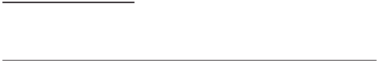

PARTICIPATION CERTIFICATE

As the riders participating in Show Jumping and Dressage are selected through Regional Equestrian League (REL) they should be provided with participation certificate. Only riders participating in Show Jumping (Normal) and Dressage will be given the participation certificate. In case of Eventing, Tent Pegging & Endurance the top 25% of the riders may be given participation certificate.

Article 513


PARTICIPATION OF HORSES IN EQUESTRIAN EVENTS

- A horse should not be allowed to participate in more than three rounds of events in a day. Maximum participation of a horse in a day is as under:-

Children Category

- Two normal Jumping rounds and one side event

OR

- Two Dressage competition and a side event of Jumping

OR

- Two rounds of Jumping normal and one Dressage competition

Junior/Young/Senior Category

  - Not more than two rounds of events (Dressage or Show Jumping).

- All Organisers/Jury/Officials will ensure to implement the new guidelines in forthcoming events.

Article 514

A standing committee consisting of members as mentioned below to take decision in case of any eventuality/contingency/situation which is/are not covered in Tech guidelines in case of ambiguity or unforeseen or circumstances, without diluting or compromising rules/guidelines by approaching as near as possible the intention or expression of Tech Guidelines/rules of NF in the best interest of the Sport:-
(a) VP Tech

(b) Secy Gen

(c) TD for the Event

(d) Rep of Ground Jury

Article 515 - 600 BLANK

 | YOUNG RIDERS DRESSAGE TEST |  |  | Appendix ‘A’
Event : .............................................. |  | Date : ......................... | Judge : ............................. | Position
Competitor No : ..................... | Name : | .......................................... | NF : ............ | Horse ........................
Time : 5.30 min (for information only) |  |  | Minimum age of horse : 4 Years
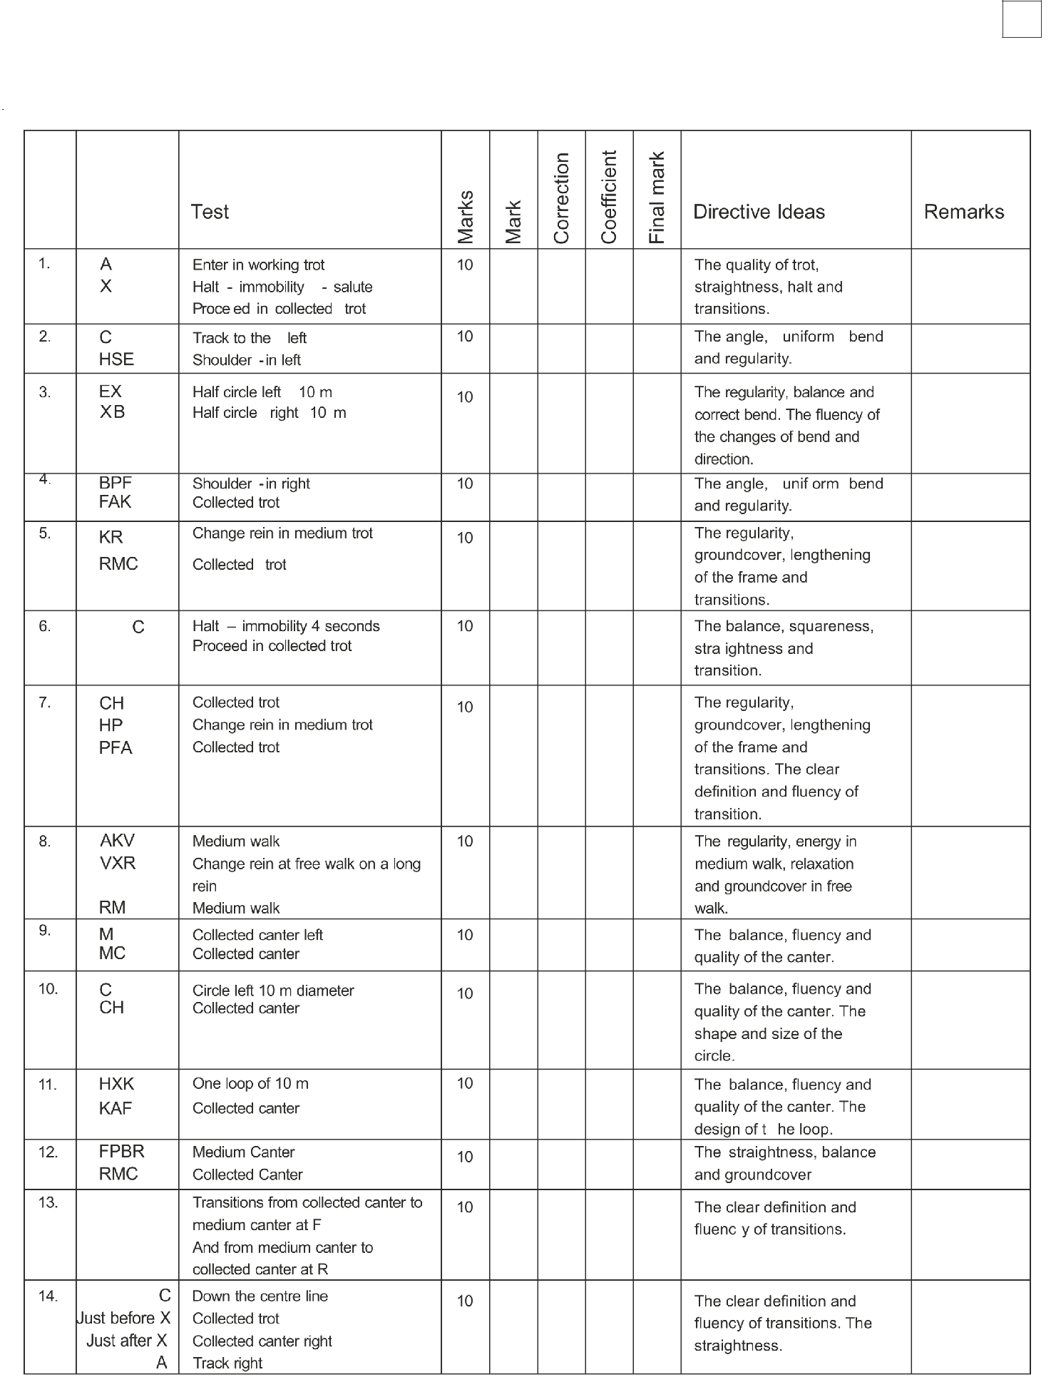

YOUNG RIDERS DRESSAGE TEST

Competitor No : ..................... Name : ........................................ Zone : .......... Horse .........................
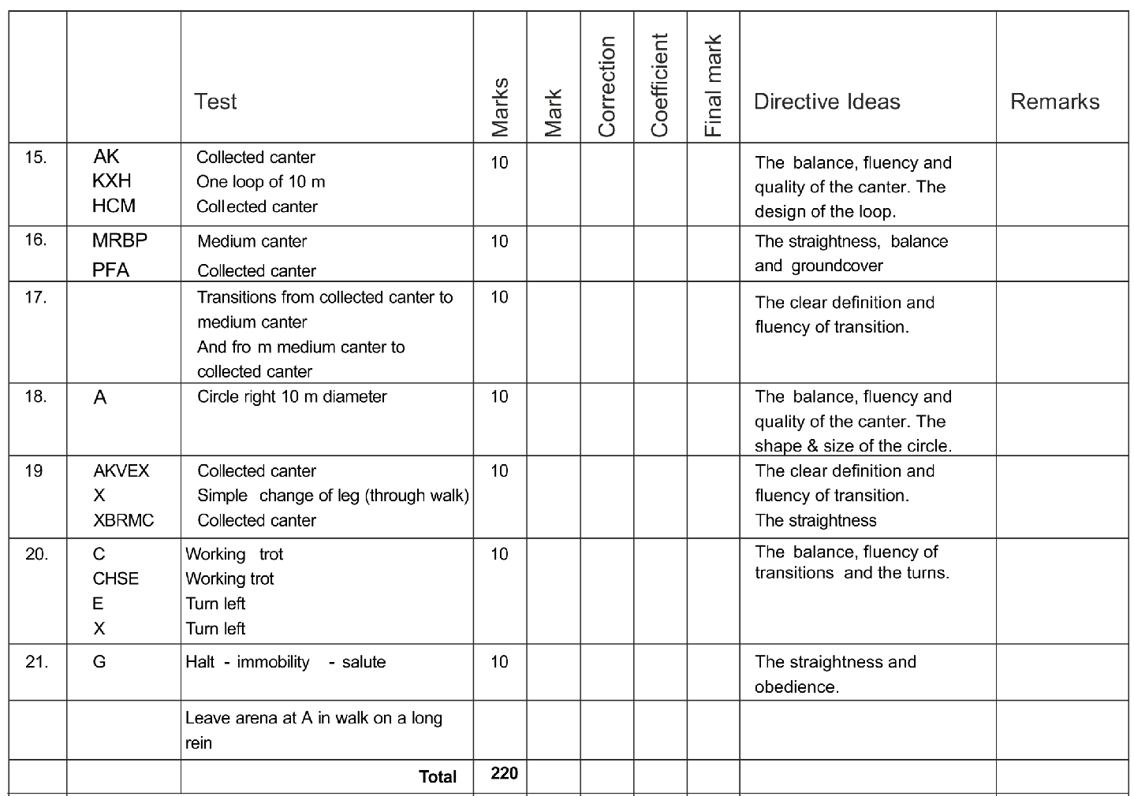

 | Collective Mark |  |  |  |  |  | General Remarks:-
1. | Rider’s position and seat, correctness and | 10 |  |  | 2
 | effect of the aids
 | Total | 240

To be deducted/Penalty Points

₁st | Error | = 0.5 point | TOTAL |  |  | TOTAL SCORE in %
2nd Error |  | = 1 point |  |  |  | TOTAL SCORE in %
₃rd | Error | = Elimination

List of errors and omissions, see Annex “Errors”

Organisers : Signature of Judge (exact address)

 |  |  |  | JUNIOR RIDERS DRESSAGE TEST |  |  |  |  |  |  |  |  |  |  | Appendix ‘B’
Event : .............................................. |  |  |  |  |  | Date : ......................... |  |  |  |  | Judge : ............................. |  |  |  | Position
Competitor No : ..................... |  |  |  | Name : |  | .......................................... |  |  |  |  | NF : ............ |  |  |  | Horse ........................
Time : 4.45 min (for information only) |  |  |  |  |  |  |  |  |  |  | Minimum age of horse : 4 Years
 |  |  | Test |  |  |  | Marks | Mark | Correction | Coefficient |  |  | Final Mark | Directive Ideas |  |  |  | Remarks
 | 1 | A | Enter in working trot |  |  |  | 10 |  |  |  |  |  |  | The quality of trot,
 |  | X | Halt - immobility - salute |  |  |  |  |  |  |  |  |  |  | straightness, halt and
 |  |  | Proceed in working trot |  |  |  |  |  |  |  |  |  |  | transitions.
 | 2 | C | Track to the right |  |  |  | 10 |  |  |  |  |  |  | The regularity,
 |  | MR | Working trot |  |  |  |  |  |  |  |  |  |  | straightness, groundcover
 |  | RBP | Medium trot |  |  |  |  |  |  |  |  |  |  | and clear difference
 |  | PF | Working trot |  |  |  |  |  |  |  |  |  |  | between working and
 |  |  |  |  |  |  |  |  |  |  |  |  |  | medium trot.
 | 3 |  | Transitions from working trot to |  |  |  | 10 |  |  |  |  |  |  | The clear definition and
 |  |  | medium trot at R |  |  |  |  |  |  |  |  |  |  | fluency of transitions.
 |  |  | And from medium trot to
 |  |  | working trot at P
 | 4 | F | Half circle 10m to D |  |  |  | 10 |  |  |  |  |  |  | The regularity, Energy and
 |  | D to B | Leg - yielding |  |  |  |  |  |  |  |  |  |  | correct positioning and
 |  | BRMCH | Working trot |  |  |  |  |  |  |  |  |  |  | control.
 | 5 | HS | Working trot |  |  |  | 10 |  |  |  |  |  |  | The regularity,
 |  | SEV | Medium trot |  |  |  |  |  |  |  |  |  |  | straightness, groundcover
 |  | VK | Working trot |  |  |  |  |  |  |  |  |  |  | and clear difference
 |  |  |  |  |  |  |  |  |  |  |  |  |  | between working and
 |  |  |  |  |  |  |  |  |  |  |  |  |  | medium trot.
 | 6 |  | Transitions from working trot to |  |  |  | 10 |  |  |  |  |  |  | The clear definition and
 |  |  | medium trot at S |  |  |  |  |  |  |  |  |  |  | fluency of transitions.
 |  |  | And from medium trot to
 |  |  | working trot at V
 | 7 | K | Half circle 10m to D |  |  |  | 10 |  |  |  |  |  |  | The regularity, Energy and
 |  | D to E | Leg - yielding |  |  |  |  |  |  |  |  |  |  | correct positioning and
 |  | ESHC | Working trot |  |  |  |  |  |  |  |  |  |  | control.
 | 8 | C | Working canter right, and circle |  |  |  | 10 |  |  |  |  |  |  | The fluency, balance of
 |  |  | right 20m diameter |  |  |  |  |  |  |  |  |  |  | the transition and canter,
 |  | CM | Working Canter |  |  |  |  |  |  |  |  |  |  | shape and size of the
 |  |  |  |  |  |  |  |  |  |  |  |  |  | circle.
 | 9 | MR | Working canter |  |  |  | 10 |  |  |  |  |  |  | The regularity,
 |  | RBP | Medium canter |  |  |  |  |  |  |  |  |  |  | straightness, groundcover
 |  | PF | Working canter |  |  |  |  |  |  |  |  |  |  | and clear difference
 |  |  |  |  |  |  |  |  |  |  |  |  |  | between working and
 |  |  |  |  |  |  |  |  |  |  |  |  |  | medium canter.
 | 10 |  | Transitions from working canter |  |  |  | 10 |  |  |  |  |  |  | The clear definition and
 |  |  | to medium canter at R |  |  |  |  |  |  |  |  |  |  | fluency of transitions
 |  |  | And from medium canter to
 |  |  | working canter at P
 | 11 | F | Half circle 10m to D, returning |  |  |  | 10 |  |  |  |  |  |  | The quality, regularity of
 |  |  | to the track at B |  |  |  |  |  |  |  |  |  |  | the canter, balance and
 |  | BRM | Counter Canter |  |  |  |  |  |  |  |  |  |  | correct positioning of the
 |  |  |  |  |  |  |  |  |  |  |  |  |  | counter canter.
 | 12 | M | Simple change of leg (through |  |  |  | 10 |  |  |  |  |  |  | The clear definition and
 |  |  | walk) |  |  |  |  |  |  |  |  |  |  | fluency of transitions. The
 |  |  |  |  |  |  |  |  |  |  |  |  |  | straightness.

JUNIOR RIDERS DRESSAGE TEST

Competitor No : ..................... Name : ........................................ Zone : .......... Horse .........................

 |  |  | Test | Marks | Mark | Correction |  | Coefficient | Mark Final |  | Directive Ideas | Remarks
13 | MC |  | Working canter | 10 |  |  |  |  |  |  | The fluency, balance of
 | C |  | Circle left 20m diameter |  |  |  |  |  |  |  | the transition and canter,
 | CH |  | Working canter |  |  |  |  |  |  |  | shape and size of the
 |  |  |  |  |  |  |  |  |  |  | circle.
14 | CHS |  | Working canter | 10 |  |  |  |  |  |  | The regularity,
 | SEV |  | Medium canter |  |  |  |  |  |  |  | straightness, groundcover
 | VK |  | Working canter |  |  |  |  |  |  |  | and clear difference
 |  |  |  |  |  |  |  |  |  |  | between working and
 |  |  |  |  |  |  |  |  |  |  | medium canter.
15 |  |  | Transitions from working canter | 10 |  |  |  |  |  |  | The clear definition and
 |  |  | to medium canter at S |  |  |  |  |  |  |  | fluency of transitions.
 |  |  | And from medium canter to
 |  |  | working canter at V
16 | K |  | Half circle 10m to D, returning | 10 |  |  |  |  |  |  | The quality, regularity of
 |  |  | to the track at E |  |  |  |  |  |  |  | the canter, balance and
 | ESH |  | Counter Canter |  |  |  |  |  |  |  | correct positioning of the
 |  |  |  |  |  |  |  |  |  |  | counter canter.
17 | H |  | Working trot | 10 |  |  |  |  |  |  | The clear definition and
 | C |  | Medium walk |  |  |  |  |  |  |  | fluency of transitions.
18 | CM |  | Medium walk | 10 |  |  |  |  |  |  | The regularity and energy
19 | ME |  | Change the rein at free walk on | 10 |  |  |  | 2 |  |  | The regularity, relaxation
 |  |  | a long rein |  |  |  |  |  |  |  | and ground cover.
20 | EV |  | Medium walk | 10 |  |  |  |  |  |  | The regularity and energy.
21 | V |  | Working trot | 10 |  |  |  |  |  |  | Transition and quality of
 | VKA |  | Working trot |  |  |  |  |  |  |  | the trot.
22 | A |  | Down the centre line | 10 |  |  |  |  |  |  | The straightness, balance
 | G |  | Halt - immobility - slaute |  |  |  |  |  |  |  | and obedience.
 |  |  | Leave arena at A in walk on a
 |  |  | long rein
 |  |  | Total | 230
 |  |  | Collective Mark |  |  |  |  |  |  |  | General Remarks:-
1. | Rider’s position and seat, correctness and |  |  | 10 |  |  |  | 2
 | effect of the aids
 |  |  | Total | 250
To be deducted/Penalty Points
1st Error |  | = 0.5 point
 |  |  |  |  | TOTAL |  |  |  |  |  | TOTAL SCORE in %
2nd Error |  | = 1 point |  |  |  |  |  |  |  |  | TOTAL SCORE in %
3rd Error |  | = Elimination

List of errors and omissions, see Annex “Errors”

Organisers : Signature of Judge (exact address)

 | CHILDREN I DRESSAGE TEST |  |  | Appendix ‘C’
Event : .............................................. |  | Date : ......................... | Judge : ............................. | Position
Competitor No : ..................... | Name : | .......................................... | NF : ............ | Horse ........................
Time : 4 min (for information only) |  |  | Minimum age of horse : 4 Years

 |  | Test | Marks |  | Mark | Correction | Coefficient | Final Mark | Directive Ideas |  |  | Remarks
1 | A | Enter in working trot |  | 10 |  |  |  |  | The quality of trot,
 | X | Halt - immobility - salute |  |  |  |  |  |  | straightness, halt and
 |  | Proceed in collected trot |  |  |  |  |  |  | transitions.
2 | C | Track to the left |  | 10 |  |  |  |  | The regularity, bend and
 | E | Turn left |  |  |  |  |  |  | balance
3 | X | Circle Left 10m |  | 10 |  |  |  |  | The regularity, bend and
 |  |  |  |  |  |  |  |  | balance including the
 | X | Circle Right 10m |  |  |  |  |  |  | fluency of the change of
 |  |  |  |  |  |  |  |  | bend and direction.
4 | XBFA | Working Trot |  | 10 |  |  |  |  | The regularity, balance
 |  |  |  |  |  |  |  |  | and energy.
5 | AC | Serpentine four equal loops |  | 10 |  |  |  |  | The regularity, balance
 |  | touching each side of the |  |  |  |  |  |  | and energy including the
 |  | arena |  |  |  |  |  |  | fluency of the changes of
 |  |  |  |  |  |  |  |  | direction.
6 | Between C&H | Working Canter left |  | 10 |  |  |  |  | The fluency and balance
 | HE | Woking Canter |  |  |  |  |  |  | of the transition and
 |  |  |  |  |  |  |  |  | canter.
7 | E | Circle left 15m diameter |  | 10 |  |  |  |  | The quality of the canter,
 | EKAF | Working Canter |  |  |  |  |  |  | shape and size of the
 |  |  |  |  |  |  |  |  | circle.
8 | FXHC | On the diagonal at X |  | 10 |  |  |  |  | The balance, fluency of
 |  | working trot, between H&C |  |  |  |  |  |  | this transition and
 |  | working canter right |  |  |  |  |  |  | straightness.
9 | CB | Working canter |  | 10 |  |  |  |  | The quality of the canter
 |  |  |  |  |  |  |  |  | and straightness.
10 | B | Circle right 15m diameter |  | 10 |  |  |  |  | The quality of the canter,
 |  |  |  |  |  |  |  |  | shape and size of the
 |  |  |  |  |  |  |  |  | circle.
11 | BFA | Working canter |  | 10 |  |  |  |  | The quality of the canter.
12 | A | Working trot |  | 10 |  |  |  |  | The balance, fluency of
 | K | Medium walk |  |  |  |  |  |  | transitions.
13 | KE | Medium walk |  | 10 |  |  |  |  | The regularity and
 |  |  |  |  |  |  |  |  | groundcover.
14 | EB | Half circle 20 meters |  | 10 |  |  | 2 |  | The regularity and
 |  | diameter free walk on a long |  |  |  |  |  |  | groundcover. The
 |  | rein |  |  |  |  |  |  | lengthening of the frame.
15 | BF | Medium Walk |  | 10 |  |  |  |  | The quality of the walk,
 | F | Working Trot |  |  |  |  |  |  | transition and trot.
16 | A | Down the centre line |  | 10 |  |  |  |  | The quality of the trot,
 | G | Halt - immobility - salute |  |  |  |  |  |  | straightness and balance
 |  |  |  |  |  |  |  |  | into the halt.
 |  | Leave arena at A in walk on
 |  | a long rein
 |  | Total | 170

CHILDREN I DRESSAGE TEST

Competitor No : ..................... |  |  |  | Name : ................................................... |  |  |  |  |  |  | Zone : .......... |  |  | Horse .........................
 |  |  | Collective Mark |  |  |  |  |  |  |  |  |  | General Remarks:-
1. |  | Rider’s position and seat, |  | correctness and | 10 |  |  |  |  | 2
 |  | effect of the aids
 |  |  |  | Total | 190
To be deducted/Penalty Points
₁st | Error |  | = 0.5 point
2nd Error |  |  | = 1 point |  |  | TOTAL |  |  |  |  |  |  | TOTAL SCORE in %
₃rd | Error |  | = Elimination

List of errors and omissions, see Annex “Errors”

Organisers : Signature of Judge (exact address)

Appendix ‘D’
DRESSAGE TEST FOR CHILDREN - II

(TO BE RIDDEN IN SNAFFLE & RISING TROT OPTIONAL)

EFI Registration No _____________________________________________________

Name _________________________________________ Horse _________________

Time : | min |  | Sec (for information only)
 |  |  | Movement | Note | Coef | Total | Remarks
 |  |  |  |  |  | Points
1 | A |  | Enter in working trot |  |  | 10
 | X | Halt-immobility-Salute
 |  |  | Proceed in working trot
2 | C |  | Track to the left |  |  | 10
 | E |  | Circle trot to the left 15m diameter
 | EKAF |  | Working trot
3 | FXH |  | Change rein in working trot (Rising) |  |  | 10
 | HCMB |  | Working trot
4 | B |  | Circle to the right 15m diameter |  |  | 10
 | BFA |  | Working trot
5 | A |  | Transition to medium walk |  |  | 10
6 | KB |  | Medium walk with lengthening of the |  |  | 10
 |  |  | frame
 | BR | Medium walk
7 | RMC | Working trot |  |  |  | 10
8 | C |  | Proceed in the working canter left |  |  | 10
9 | E |  | Circle to the left 20m diameter |  |  | 10
10 | EKAF |  | Working canter |  |  | 10
11 | FB |  | Working trot |  |  | 10
12 | BE |  | Half circle to the left 20m diameter |  |  | 10
 | EB |  | Change of hand through an “S”
 |  |  | inside the 20m circle
 | BE |  | Half circle to the right 20m diameter
 | EHC |  | Working trot
13 | C |  | Proceed in working canter right |  |  | 10
 | CMB |  | Working canter
14 | B |  | Circle to the right 20m diameter |  |  | 10
 | BF |  | Working canter

DRESSAGE TEST FOR CHILDREN - II

(TO BE RIDDEN IN SNAFFLE & RISING TROT OPTIONAL)

EFI Registration No _____________________________________________________

Name _________________________________________ Horse _________________

 | 15 |  |  | F | Working trot |  |  |  |  |  |  |  |  | 10
 | 16 |  |  | A | Down center line |  |  |  |  |  |  |  |  | 10
 |  |  |  | I | Halt-immobility-salute
 |  |  |  |  | Leave the arena in walk on a long
 |  |  |  |  | rein
 |  |  |  |  |  |  |  |  |  | Total |  |  |  | 160
 | Collective Marks
 | 1 | Rider’s position and seat, |  |  |  | 10 |  |  |  | 2
 |  |  | correctness and effect of the
 |  |  | aids
 |  |  |  |  | Total | 180

To be deducted
1st Time | = 0.5 mark
 | TOTAL |  |  | TOTAL SCORE in %
2nd Time | = 1 mark
3rd Time | = Elimination

List of errors and omissions, see Annex “Errors”

Organisers : Signature of Judge (exact address)

Appendix ‘E’

DRESSAGE TEST FOR JNEC EVENTING

EFI Registration No _____________________________________________________

Name _________________________________________ Horse _______________

Time: 4 min 30 Sec (for information only)

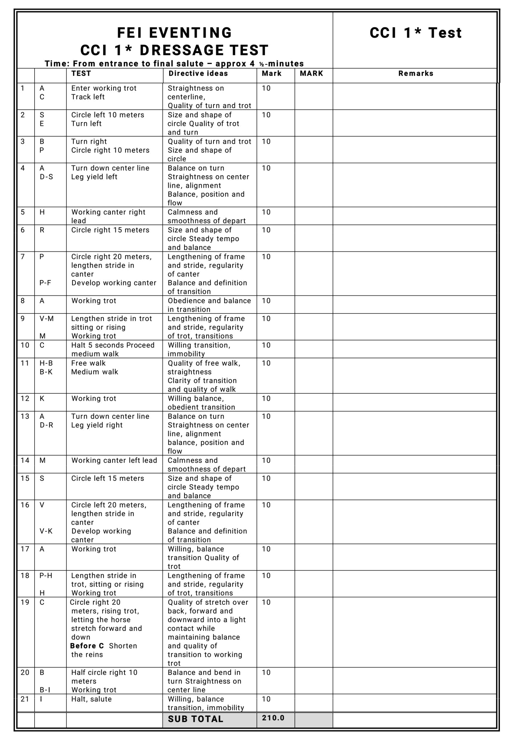

Signature of Judge: _____________________________

DRESSAGE TEST FOR JNEC EVENTING

EFI Registration No _____________________________________________

Name _______________________________ Horse _________________

Time: 4 min 30 Sec (for information only)
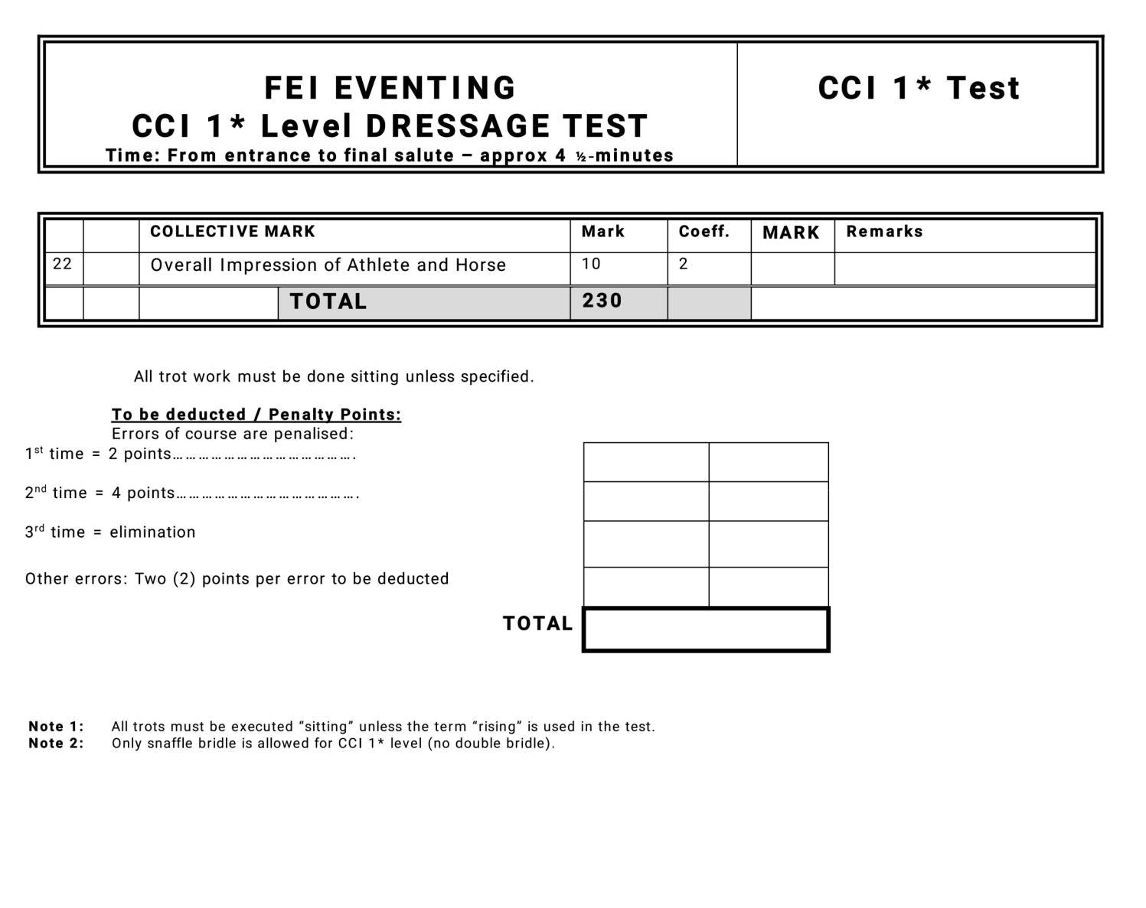

Organisers : Signature of Judge (exact address)

